Archives of Maryland
(Biographical Series)
Charles H. Houston (1885-1950)
MSA SC 3520-
Biography |  |  |  | Images
Sources |  |  |  | Related  Collections
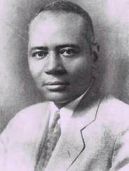
Cornell University, Charles Hamilton Houston: A Gallery,
http://www.law.cornell.edu/houston/housbio.htm
This information resource of the Maryland State Archives is presented here for fair use in the public domain. When this material is used, in whole or in part, proper citation and credit must be attributed to the Maryland State Archives. PLEASE NOTE: Rights assessment for associated source material is the responsibility of the user.

Tell Us What You Think About the Maryland State Archives Website!

[ Archives' Home Page || All About Maryland || Maryland Manual On-Line || Reference & Research
|| Search the Archives || Education & Outreach || Archives of Maryland Online ]
Governor General Assembly Judiciary Maryland.Gov
© Copyright October 27, 2005 Maryland State Archives
Archives of Maryland
(Biographical Series)
Charles H. Houston (1885-1950)
MSA SC 3520-
Born September 3, 1885 in Washington, D.C. Graduate of Dunbar High School, Amherst College, and Harvard Law School. First African-American Editor of Harvard Law Review. Lieutenant, 351st Field Artillery, 1918-1919, during World War I. Member of firm of Houston, Houston & Hastie. Attorney in Pearson v. Murray, 169 Md. 478 (1936); Missouri ex rel. Gaines v. Canada, 305 U.S. 337 (1938); Shelley v. Kraemer, 334 U.S. 1, 23 (1948).
Charles H. Houston, a leading attorney for the NAACP, participated in dozens of major civil rights litigation over the course of three decades. He gained admittance to the University of Maryland law school for Donald Gaines Murray in 1936 with his co-counsel William Gosnell and a young Thurgood Marshall. Two years later, he built on that victory in a case against the University of Missouri law school, getting the Supreme Court to recognize the law created in Maryland’s highest court. He also desegregated Maryland’s Pratt Library training classes and the University of Maryland Nursing School.
Mr. Houston, a mentor of Thurgood Marshall, played a part in nearly every major civil rights case for three decades, before he died in 1950 at the age of 55, the victim of a heart attack. In addition to being special counsel to the NAACP, he was a member of the firm of Houston, Houston & Hastie, with Judge William H. Hastie, who served on the Third Circuit Court of Appeals. Mr. Houston also served as a professor and Dean of Howard University Law School and a member of President Truman’s Fair Employment Practice Committee before his death in 1950 at the age of 54.
Return to Charles Houston’s Introductory Page

This information resource of the Maryland State Archives is presented here for fair use in the public domain. When this material is used, in whole or in part, proper citation and credit must be attributed to the Maryland State Archives. PLEASE NOTE: Rights assessment for associated source material is the responsibility of the user.

Tell Us What You Think About the Maryland State Archives Website!

[ Archives' Home Page || All About Maryland || Maryland Manual On-Line || Reference & Research
|| Search the Archives || Education & Outreach || Archives of Maryland Online ]
Governor General Assembly Judiciary Maryland.Gov
© Copyright October 27, 2005 Maryland State Archives
Archives of Maryland
(Biographical Series)
Charles H. Houston (1885-1950)
MSA SC 3520-

Sources:

“Heart Attack Fatal to Charles Houston,” Baltimore Afro-American, 29 April 1950.
“Charles Hamilton Houston,” Afro-American, 29 April 1950.
All Photos from Charles Hamilton Houston: A Gallery, http://www.law.cornell.edu/houston/housbio.htm.
Return to Charles Houston’s Introductory Page

This information resource of the Maryland State Archives is presented here for fair use in the public domain. When this material is used, in whole or in part, proper citation and credit must be attributed to the Maryland State Archives. PLEASE NOTE: Rights assessment for associated source material is the responsibility of the user.

Tell Us What You Think About the Maryland State Archives Website!

[ Archives' Home Page || All About Maryland || Maryland Manual On-Line || Reference & Research
|| Search the Archives || Education & Outreach || Archives of Maryland Online ]
Governor General Assembly Judiciary Maryland.Gov
© Copyright October 27, 2005 Maryland State Archives

Archives of Maryland
(Biographical Series)
Charles H. Houston (1885-1950)
MSA SC 3520-
Images:
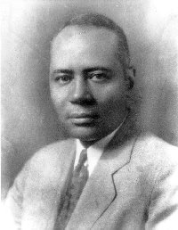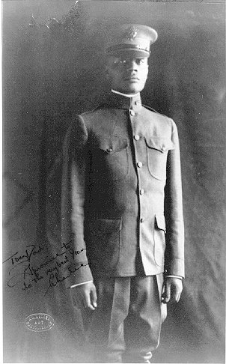

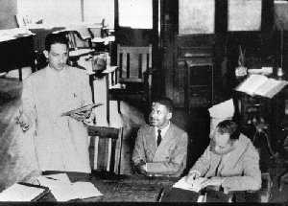
Middle, in Pearson v. Murray with Thurgood Marshall.
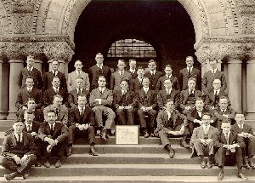

With the members of the Harvard Law Review.
Return to Charles Houston’s Introductory Page
This information resource of the Maryland State Archives is presented here for fair use in the public domain. When this material is used, in whole or in part, proper citation and credit must be attributed to the Maryland State Archives. PLEASE NOTE: Rights assessment for associated source material is the responsibility of the user.

Tell Us What You Think About the Maryland State Archives Website!

[ Archives' Home Page || All About Maryland || Maryland Manual On-Line || Reference & Research
|| Search the Archives || Education & Outreach || Archives of Maryland Online ]
Governor General Assembly Judiciary Maryland.Gov
© Copyright October 27, 2005 Maryland State Archives
Archives of Maryland
(Biographical Series)
Charles H. Houston (1885-1950)
Related Collections:
R. Garland Chissell, et al v. Mayor and City Council of Baltimore Papers Collection, MSA SC 5905.

Return to Charles Houston’s Introductory Page

This information resource of the Maryland State Archives is presented here for fair use in the public domain. When this material is used, in whole or in part, proper citation and credit must be attributed to the Maryland State Archives. PLEASE NOTE: Rights assessment for associated source material is the responsibility of the user.

Tell Us What You Think About the Maryland State Archives Website!

[ Archives' Home Page || All About Maryland || Maryland Manual On-Line || Reference & Research
|| Search the Archives || Education & Outreach || Archives of Maryland Online ]
Governor General Assembly Judiciary Maryland.Gov
© Copyright October 27, 2005 Maryland State Archives

